ASSIGNMENT 1

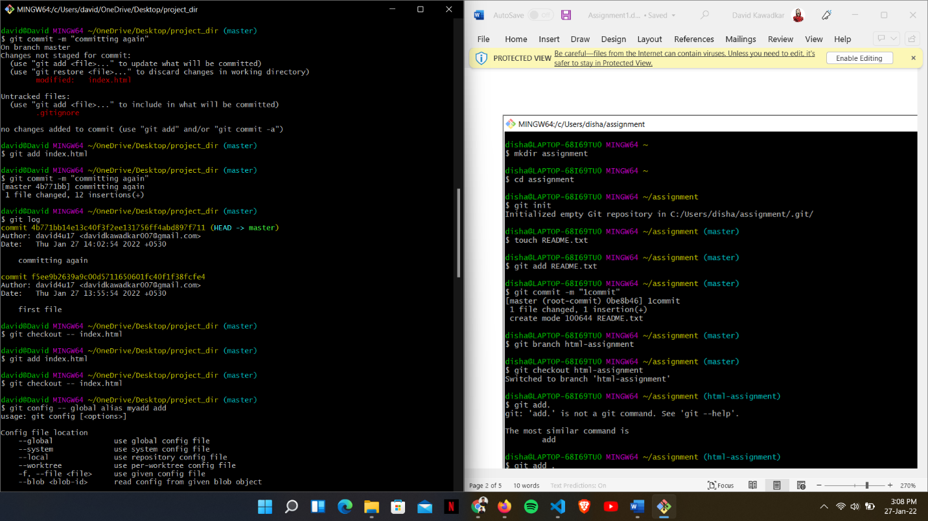

GIT BRANCHING

SECTION-1

SECTION-2

SECTION-3

